The CJ Whisperer and the Start Valve

By Craig Payne

Back in 2010, I wrote a short article for the Red Alert on maintaining the QDF-1 or the air start valve. I remember rambling on about regular air system maintenance, especially when doing the General Condition Inspection; mandated by the Operation Limitations to be done once per year. It’s an annual by any other name.
So this year I happen to skip that step since I only had about 35 or so hours since the last annual. Blame it on the Flap. It hit the dirt when the Gear partially collapsed; allegedly caused by the Pilot during a sharp turn on the grass next to Oshkosh 9-27 at high speed. When the FAA came to investigate, the Pilot took the 5th, the Wingtips were bent, the Flap was trashed and the Gear survived ok. The Wingtips got a light sentence since they were non-structural and the Flap hid his bent ends with the connivance of Wing who prevented the prying eyes of the FAA to see Flap. So it ended up that Gear took the hit with Pilot suspected but not proven to be an accomplice. Wingtips got punished with wooden mallets on a leather pad until back on the straight and narrow. Flap stayed hidden but worked good enough to get home.
So how did Start Valve get involved? It was supposed to sit by quietly while the Mechanic rebuilt a spare Flap and hung it under the Wing. But it didn’t take kindly to sitting there in the hanger with nothing to do for three months.
So how do I know all this? Well, an airplane “talks” to you if you care to listen. I failed to listen when I finally got around to fixing the Flap and installing some new engine mods. The darn engine would not start no matter what I did. Finally I sat down in despair, head in my hands at my workbench, littered with empty beer cans and spoke to my CJ…
“CJ, why do you do me like you do?” I whined.
“Well” said she said in her feminine whisper, “you neglected my Start Valve during the annual, you let rust blow up from the lower end of my Start Valve after sitting 3 months in Florida heat and humidity, then you half-assed energized my solenoid with a partially discharged battery, and you fed me wet air on top of that”.
“I’m sorry, I’ve been so distracted lately, what I can I do to make it up to you”, I said?
CJ paused for a while and then spoke slowly. “Take my Start Valve apart, carefully clean it, remove any rust, install clean new springs both in my valve body and solenoid, give me new O-rings, and seals from Uncle Doug Sapp, and lightly lube with air tool oil , then re-assemble carefully.
“Is that all there is to it”? I asked. “Well, noooo” she said, “I must have plenty of juice from a fully charged battery, and dry air from a freshly-serviced air-water filter. BTW, that lead from the Start Coil is broken so only the mags will provide a start and Start valve can’t spin Engine fast enough”.
“OK, it’s a deal”, I said. Shortly after that, Start Valve promptly did her job when the Pilot asked for assistance during the start and the Mechanic went to the hanger fridge for a cold one.
Epilog: Someday, you too could be caught with your Head held in your Hands in desperation, making quite a sad picture framed by empty beer cans lying about the hanger, all because you neglected Start Valve. Don’t piss off Start Valve, keep her happy.

Start Valves and Parts
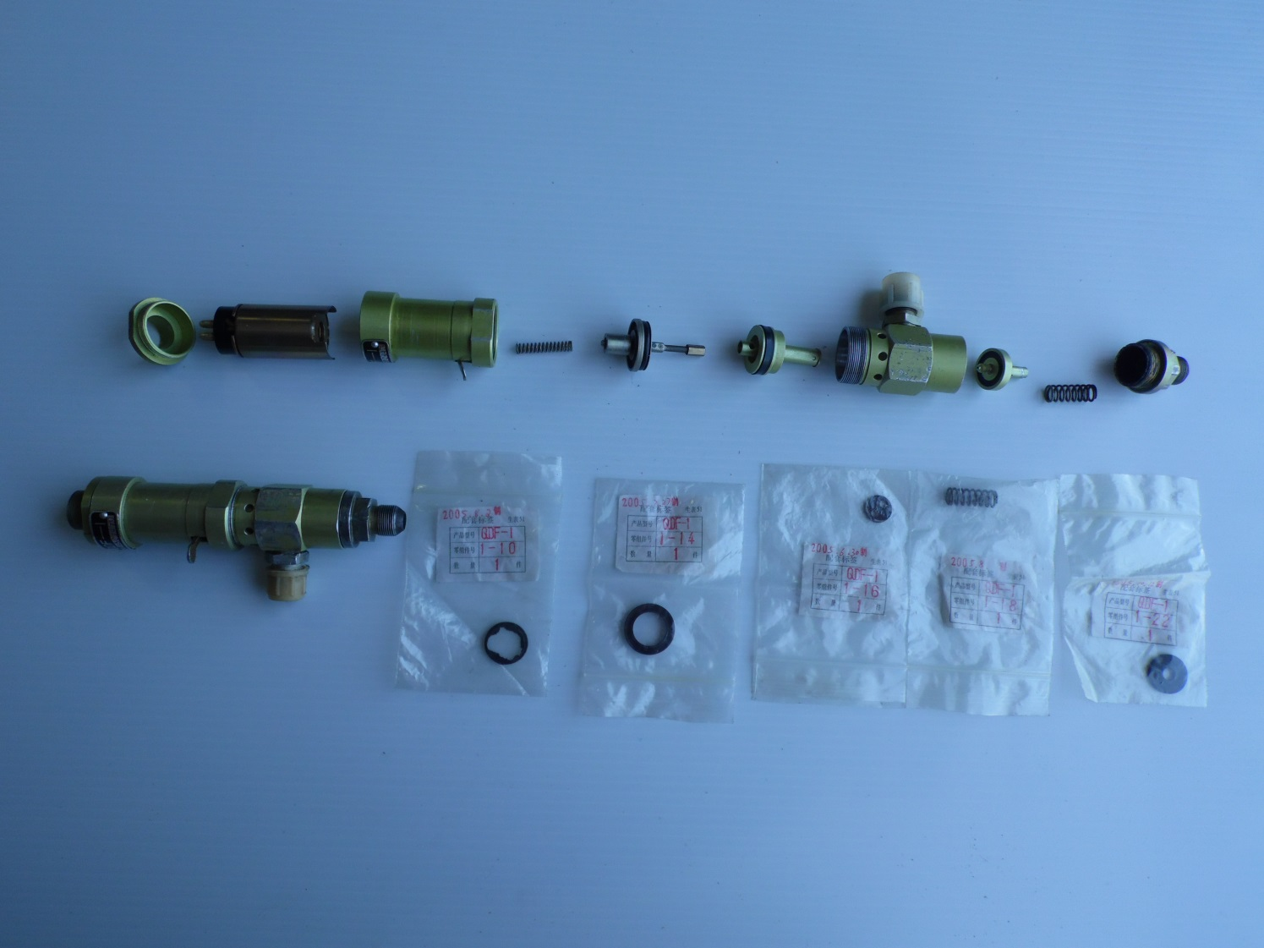

Tab fitted into Solenoid wide slot
