Yak Hacks
By Craig Payne
Well, not just Yaks, but CJ’s and similar Red Star type aircraft as well. So what is a “Hack”? In today’s popular culture, the term has been extended from the computer world to mean just about any kind of work-around or shortcut to get a job done. That’s what I’m referring to here when working on these aircraft.
Why would a Yak need to be hacked? The primary reason is not having the correct part or Metric hardware handy to make a repair. Some repairs must always use the correct part or hardware but many items can be substituted, some “hacks” are even better than stock parts.
Rule-of-Thumb: Use Aircraft Hardware rather than the metric stuff from the Aircraft Certified Equipment (ACE) hardware store. Aircraft bolts are made with rolled threads, not cut, and they are yellow zinc-cadmium plated, made specifically for the job.

Common Substitutions:
- Use 3-1/8” diameter U.S. instruments to replace factory metric instruments. The holes are the same size but calibration is in different units. Curiously, the smaller holes also fit the 2-1/4” U.S. instruments sizes. I guess designers chose not to re-invent what was already available.
- For non-structural sheet metal parts, use .025” thick 2024-T3 aluminum in place of the .027” thick metric stuff. For structural repairs, use .032” size with 1/8” rivets.
- Bolt and Nut Substitutions: Non-critical usage only.
  - DIN spec metric hardware, not made for aerospace use but generally useable.
  - Use 8-32 size screws (.164” dia.) to replace M4 size (.157” dia.) if the hole is big enough.
  - Use 10-32 size AN 3 bolts (.190” dia.) in place of M5 bolts (.197” dia.)
  - Use ¼-28 size AN4 bolts (.250” dia.) in place of M5 bolts (.236” dia.) if the hole is big enough.
- Use ¼” 5052 aluminum tubing to replace air lines. The “B” nut must be drilled with a 5/16” bit to accept the AN818-4 sleeve couplings.
- Use Aeroquip 303 hose in place of metric oil hose, re-using the metric fittings. Other industrial hose types from Gates provide a better fit, offer superior strength and temperature ratings. The pipe thread used in these airplanes is the same size as SAE, which allows the opportunity to convert to an SAE hose fitting on the other side.
- 5606 hydraulic fluid works fine in the struts and Granville strut seal works its magic just as well as in certified U.S. aircraft.
- Aeroshell #5 for prop bearings. I use it in wheel bearings also.
- Bearings: All bearing manufacturers in the world use a similar numbering system. Match or cross-reference the numbers and the bearings match. I buy my wheel bearings locally.
- Many CJ-6 parts and Yak-52 parts interchange. Wheels, tires and brake parts as well as other airframe accessories.
- Use the Chinese CD-5 magneto on the M-14P engine. The timing must be set differently but the CD-5 advances the spark automatically and it is cheaper than the M-9F magneto. However, although it can be done, do not use the M9F on the Huosai engine since there is no centrifugal advance. The Wilga M9 magneto looks “exactly” like the Chinese CD-5 and has auto-advance as well. I found one in 2013 on eBay cheap; and it was new old stock in the box!
- Some of the J1-9 and V-530 prop parts also interchange. The hub seals, dome (with some alteration) and dome seals as well as the brass sliders. Seals are the most commonly used maintenance items on these props.

Short Cuts:
- On CJ’s, during gear retraction testing, the gear can slam down quite hard, even with low air pressure and flow restrictors. Remove the Upper gear well covers and make a safety wire loop on both ends of a 30” piece of wire. Hook one end over the gear up-hook release lever and thread out towards the wingtips, over the upper cover. After the gear is unhooked from the down locked position by minimum air pressure, swing up the wheel by hand until it locks. With the upper cover removed it is easy to inspect with a light. Stand clear and pull the safety wire to release each gear leg. I catch the wheel before it locks and can repeat as necessary to adjust the fit of the gear doors or check the adjustment of the lock hook. The nose gear can also be released manually. The final test will be with air pressure after all else is verified.
- Lack a tail stand for the retraction test? I use a wooden saw horse with two cement bags on a shelf underneath. The tail loop tie down is the bolted to the sawhorse with a metal U-clamp.
- Does your Yak-52TW suffer from high oil temps during summer operation? Remove the oil filler cover and fly without, this allows air flow over the oil tank. Or, build a cover with built-in air scoop and exhaust vent.

After-Market Hacks:
- Stainless steel Air-Water separator: keep the air system dry and the rest of the system will benefit from lower maintenance. The importance of this cannot be understated for pneumatic system airframes. Yaks tend to lack this nicety and suffer for the lack of one. Call Doug Sapp.
- Air filter: Some Yaks do not have one but Brackett makes a foam slip-on for the Nanchang. Air filters keep out the silica which accelerates wear in any engine. The Yak can be retrofitted with a one-off solution and that would be well worth the effort.
- Oil Filter: The installation of a 20 gallon-per-minute, 10 micron filter will remove a lot of silica (dirt) that causes wear to metal parts inside the engine. Extend the usable life of the engine with a remote mounted oil filter. These filters also trap destructive metal particles and have been known to get airplanes home that would have otherwise failed in route.
- Automotive Wire conversions: A careful install will side step many hours of maintenance and miss-firing issues with the stock system. After market sparks plugs are cheap and good. Take care to gap properly; no more than .020” for standard magnetos or the magneto coil may overheat at altitude.
- Almost every owner uses a stainless steel exhaust system. There may a stock CJ-6 out there with a steel system but it will not last for long! Go Stainless now.
- Everyone knows that Desser Tire carries U.S. made metric tires, right? Their cores can be recapped at least twice and recaps last longer than the original. In my experience, Desser recapped Russian or Chinese cores last much longer than single compound, OEM tires. I use a Baron nose wheel conversion on my CJ-6 for both `lower tire cost and the reduced maintenance with sealed bearings.
- Enable use of 12V instruments and equipment by installing a 24VDC to 12VDC converter. My brand of choice is Pyle. They manufacture audio quality equipment of good quality and low price. The Pyle PSWNV480 will deliver 480 watts at 12VDC and handle most equipment needs, including the trigger voltage for my electronic ignition. Pyle also makes low-cost units of less and greater capacity.
- The most useful “hack” I have installed is the rudder pedal mod that allow my legs to stretch out on a cross country. Prior to that, each flight was a lot shorter due to the discomfort of a hard parachute and not being able to stretch out. Short legged people will not understand this.
- A popular “hack” is to install adjustable rudder trim and aileron trim; especially on CJ-6’s used for cross-country cruising. At gatherings like Oshkosh, numerous examples can be spotted. Some manual, some are added for autopilot use. See Figures 1 and 2

Parts Supply Issues:
Some parts regarded as “wear items” are in short supply since they are no longer in production. Ignition components come to mind but carburation is not far behind. Automotive wiring conversions solve some big problems, and mag coil rewinding solves another but long term “hacks” are needed.
- Automotive point conversion: M14.com has developed a replacement. I have built up a few units for testing but have not sold any. In the near future, conversions like this will be part of a magneto overhaul.
- Magneto coils: I have run an electronic mag conversion for about 3 years now. The coil was removed and off-the-shelf automotive components were used along with my custom distributor cap. So far it has been robust and reliable. Barrett Precision Engines offer a dual eMag type of setup, complete with wiring and coils that is state of the art but may be expensive for some pocketbooks.
- Carburation: Perhaps I should say “fuel delivery system”. Air Performance already has a compatible throttle body unit and Barrett/Kimball have an improved injector nozzle for it. Not cheap but several automotive setups designed to swap out carburetors are marketed. They are programmable and some can “learn” the engine you adapt it to. They run about half the cost of the Air Performance unit. “Some experimentation required” would be the disclaimer here.

Future Hacks:
The Yak/CJ airframes are strong. The Yaks especially and combined with low airframe times, I see plenty of life left in them. Could you imagine a Chevy crate engine conversion to replace the Huosai? It’s been in my mind even before the “LS” series V-8’s were available. At AirVenture 2015, I saw two such conversions, complete with reduction units. How about electric replacing the pneumatics? That’s something I wish for every time “stuff” happens. Of course then, we love these airplanes for what they are….right?

Figure 1: Rudder Trim tab on CJ
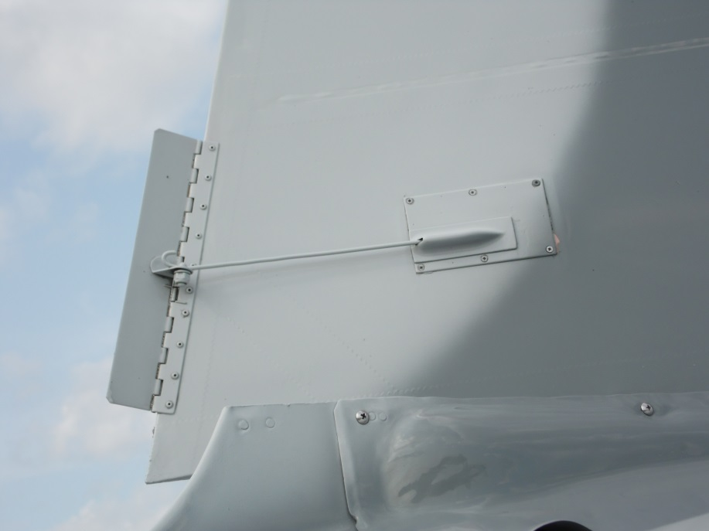

Figure 2: Rudder Trim tab on CJ
