Hail the Lowly Start Coil

By Craig Payne

Every engine start on the standard Huosai or M-14P engine begins with three ingredients: a charged battery, a sufficient supply of pressurized air, and gasoline. While I have focused previous Red Alert articles on the Start Valve, I have neglected the Start Coil. This device is actually a vibrating spark generator, often called a “shower of sparks”, which is a bit different but does the same job, also a “boost coil” or “vibrating coil”. See Figure 1.
Operation: The start coil on the Yak and CJ is interchangeable. Its function is to turn 24VDC energy into high voltage pulses that fire the spark plugs and does so by using vibrating points that open and close the primary of the coil. The high voltage side of the coil is connected to the magneto trailing lead on the rotor, set 25° retarded from the main spark lead. See Figure 2. This applies that “shower of sparks” to each spark plug in turn as each cylinder nears Top Dead Center on the compression stroke. Spinning the cylinder is air pressure routed by the air “spider” which is supplied high pressure air via the Start Valve. All of this begins with pushing the start button. Of course the cylinders need to have gasoline vapor in them so they will fire when the start coil voltage reaches each plug.
Once firing, the magnetos are switched on and the switch is released. The start coil de-energizes and the start valve closes as both of their jobs are done. So why not just start with magnetos without the secondary sparking circuit? Well the problem is that the magnetos are NOT impulse coupled which engines with fewer cylinders have. Fewer cylinders mean more degrees of rotation to store the spring energy to provide that “snap” of spark. The Huosai CD-5 mags handle the start job better than the M9F fixed mags found in most Yaks as the have a centrifugal advance but they still need help from start coil when the prop turns slowly.
Start Sequence: Only Three hands required!
- Engine prime as necessary. I pull my prime through a couple of blades
- Master and Start breaker/switches on
- Throttle set to start position
- Open the Main air valve; system pressurizes
- Press the Start switch
  - Start Solenoid energizes and routes high pressure air to air “spider”
  - Start Coil generates sparks which transfer to the trailing finger on the mag cap
- Engine fires (or not) more fuel priming may needed
  - Flip on the Mags “ON”
  - Release the start switch when engine “catches”
- Throttle/Prime as required.
Failure Modes: Generally the coil lasts the life of the engine. What causes premature failure is moisture and/or oil contamination on the points or in the output side where high voltage can gradually breakdown the insulation. On the Magneto end, check that the incoming lead is making a good connection and that Distributor Rotor trailing finger is “clean” from oxidation. See Figure 3.
Maintenance: Keep the unit clean and during the general condition inspection, open the cover to verify that the insides are clean and dry without visible burn marks. I use a little silicone sealant on the upper/lower case halves to form a seal because the unit did not come with a gasket. See Figure 4.
Troubleshooting: Measure resistance through the primary inputs, with one or both input leads disconnected. Resistance should be 1.2 Ohms. Also measure from the high voltage output side of the coil to the case which is grounded through a tab on the end opposite the input wires. Resistance should measure about 7000 Ohms. Look for obvious burn-through shorts, etc. on the output line. Input DC voltage should be measured on the incoming leads when the start switch is pushed. (Master and Start breakers on). See Figure 5.
Modifications: Numerous CJ’s were modified with oil tank shutoff valves. Protection against starting without oil was provided by routing the start switch voltage through the relay. Thus if the oil tank switch is not open, the “Start” switch function is disabled. That is the theory. If one or more of the relay connection pairs is defective, the engine will not start….unless the relay is “broke” and the pilot uses the Yak foot start. (An after-market addition to my CJ) This results in the engine starting but maybe without oil. I started my CJ-6 this way in a high stress situation at an airshow and it cost about $13,000 for an overhaul. It’s not so cheap anymore in today’s dollars.
Disclaimer: Opinions expressed here are solely from the author’s experience. Of course the reader can find alternative opinions of the internet, especially on blogs for these aircraft. Someone *always* has a better way, in theory that is. Pick your poison
Figure 1 – New Start Coil with spares
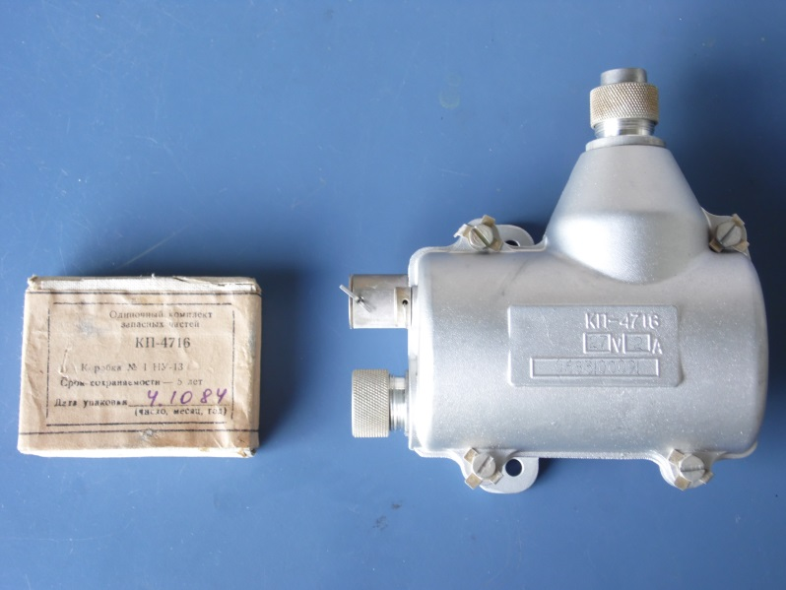
Figure 2 - Mag Rotor
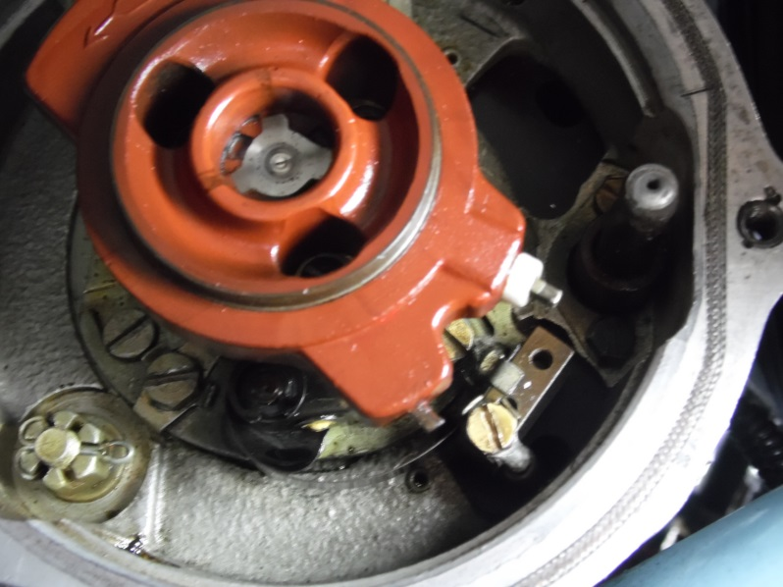
Figure 3 - Burned coil body
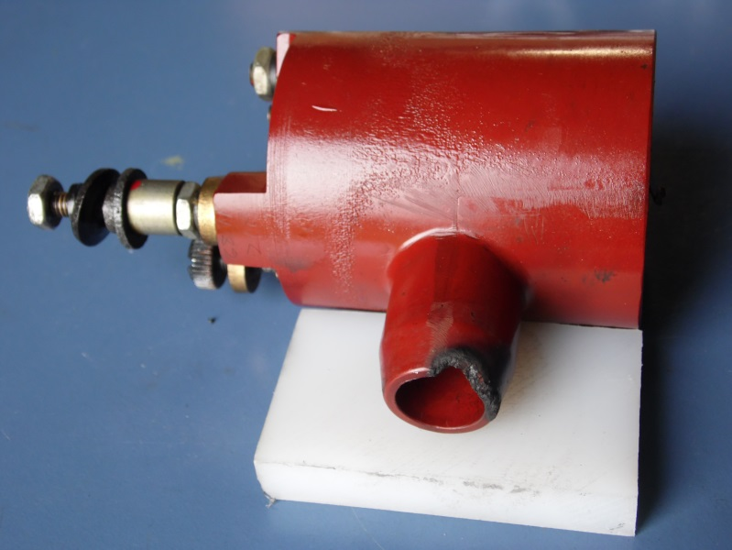
Figure 4 - Sealing the case
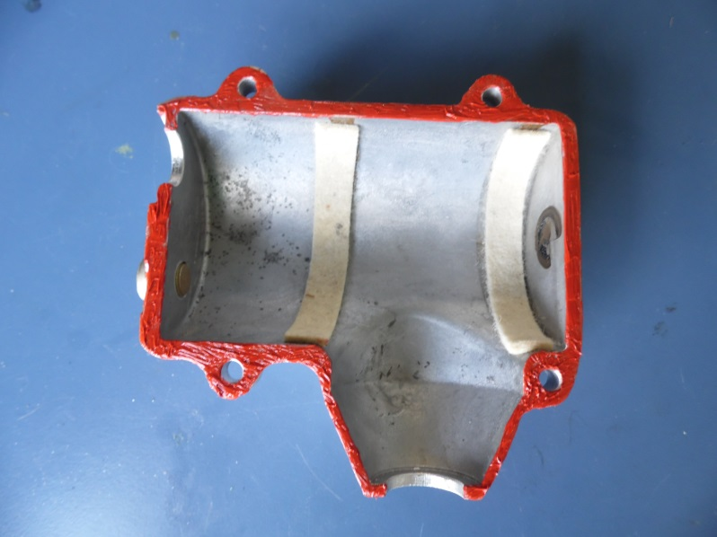
Figure 5 – Installed view with custom output lead
