Running the Air Venture Cup Race…in a CJ-6!
By Craig Payne
Some 13 or so years ago, the AirVenture cup race was established to revive cross-country air racing which had mostly died out years before. The route changes but the destination is always somewhere near Oshkosh on the day before AirVenture starts. I always thought that it could be fun to race but the main obstacle was the limited fuel capacity of the CJ-6, especially with an M-14P engine. Previously I had run my CJ-6 in several short races with good results. Another motivator for racing was my anger over the hack job on the Nanchang as published in the AOPA magazine.
This year, sub-classes for Yak and CJ-6’s were added under the “Heavy Metal” category, and a “no penalty” fuel stop was allowed. Another factor was the starting point which changes from year to year. This year the race started from Mt. Vernon, IL which is just east of St. Louis and close enough to my route from Florida to make the detour. The race course ran north 364.8 NM to Wisconsin Rapids and the turned east to Waupaca for 35.3 NM for a total of 400 NM. Oshkosh is about 30 SW from there.
So I coughed up a $270 entry fee, which turned out to be worth three meals, some beers and a bus ride, I’m told more was available but details were never briefed. Administrative overhead got the rest I guess. Additionally, there was the hotel bill at Mt. Vernon and the fuel to get there. I had called ahead for hanger space so I could prep for the race the day before. Then there was plenty of paperwork, insurance certs, waivers; all stuff needed to cover butt when something went wrong.
My problem; N285CJ ain’t what she used to be since I removed the performance engine and sold my Crowder spinner to “Med”. He needed it to complete a Flying Tiger look on his CJ. Worked out great for him but I ended up losing a bunch of knots. All I could do was tune the engine, tweek the trim tabs for 170 knots and “race tape” the airframe in critical areas such as joints. Throw in a few temporary fairings, a liberal dose of MMO in the fuel and engine, a wax job and I was ready. The M-14P with paddle blade prop is stock except for my electronic mag conversion and my own spark plug wire upgrade. A temporary induction ram air mod helped a bit too.
After some testing and calculations, I figured my 14 gallon aux tank would provide a reserve to the 40 useable in the mains so I could run 200 NM at 80% power to make a fuel stop, factoring in a 30 mph headwind. It turned out to be a 12 mph headwind to the stop so everything was good.
Lots of interesting airplanes and pilots showed up for the event as well as a shorter race on Saturday, run by the Sport Air Racing League (SARL). Some big names in the business, like Klaus Savier of Lightspeed and a couple of Reno racers showed up as well. The only airplane that looked comparable in size, weight and performance was a Comanche 400 piloted by a couple of young bloods on their first outing. I ended up that I edged them by less than 1 mph.

The Race
A flying start was used, each plane departed single ship and then circled back over the start line at 1000 AGL to clock the start time. My start was towards the end of the line-up as my speed would be rather slow in comparison to the rest. The “rest” included 48 planes, most were Lancairs, Glassairs, canards, a couple of Turbine Legends, both a GP4 and the only GP5 flying, Swearingen SX300’s, plenty of RV’s and an odd assortment of factory-builts.
My start went well and soon I settled in on the 356⁰ heading and spotted a few guys up ahead of me in the clear air. Playing with the shutters, oil cooler door and trim, I finally found settings I was happy with, trueing out over 200 mph, and getting 190 mph ground speed at 1200 AGL. RPM was set to 2400 and throttle WFO, burning 23.5 GPH. After a while I spotted what looked like big white birds same as we see in Florida. Those birds kept getting bigger and soon I was passing some airplanes. One Vari-EZ had a sick E-Mag and the Diamond was just slow. A few more planes passed under my wing and at the halfway mark I overflew the fuel stop at Dixon, IL to stop the clock and landed.
So far so good but now Murphy joined in the fun. The re-start was never really briefed in detail, because all the SARL guys knew how it worked. I turned back on the direction I came from to gain altitude and airspeed for the in-bound restart leg. As with the previous start I called in at 2 miles. The reply I got was that the clock was restarted as I was supposed to call in over airport center. My protest was in vain since the timers were sitting about a ¼ mile from airport center at that time and all they had was the radio call to mark. Oh well, what’s an extra 2 miles anyway.
Northern Illinois terrain slopes up a bit towards Wisconsin, over some ridges and now there was a ceiling at 1100 AGL, with stronger winds as well. Bumpy air resulting from wind flowing over the glacial mounds added to the sensation of speed. As the Wisconsin Rapids airport turn came up, I spotted an RV ahead about 3/4 mile but I lost him in the turn, tough bugger to spot under a gray sky.
The east-bound heading was better; ground speed went up to over 200 knots and it all seemed down-hill. About 3 miles out I heard the RV calling in at the same distance as I was from the finish. At 200 knots there was only seconds to sort out where he was so I lowered my nose to look. As I crossed the finish the RV shot upward from under my nose to a pitchout 50 yards in front. Surprise is understating the effect. Hmmm, that was a lot lower than the briefed arrival. I followed him for a bit waiting for his in-bound turn but it never came. A radio call confirmed that he was not stopping there for the cheap gas so I turned back.
As I taxied up at Waupaca, the line boy must have figured I was a transit and not a racer so he parked me away from the line at the pump. By the time I got it sorted, I was next to last for fuel. An hour and a half later and I was off for Oshkosh. It was neat to overfly the field at 3500 and then slice down into the Warbird arrival through smooth air at 190 knots. Sunday afternoon and the North 40 was almost full and the South 40 filling up. After about 5 unanswered calls, I gave up calling tower and headed in for an overhead break. Tower spotted me and had called a mid-field break to sequence on the downwind.
Later, a rented bus took all of us down to Wendt’s on the lake for dinner. Really good local beer was furnished and I had a great piece of fish to wash down. At the awards ceremony, my first leg time was clocked at 191 MPH, and numerous folks were surprised a CJ-6 would go that fast for such a distance. Perhaps they believed what they read in the AOPA “fly-off”?
Later my time was re-adjusted to 187 MPH overall; my 2 mile screw-up and headwinds took their toll. My award? Well, 1st Place in Heavy Metal. I have been explaining that I also placed 2nd and 3rd, since I was the only entry. So now the bar is set since this was the first run of a CJ-6 in a SARL race. The SARL Heavy Metal Yak class record is 116 mph in a Yak-52. Come on guys, I know you can do better than that.
Met many interesting folks as well and picked up some speed tricks too. The 2014 race will start from South Dakota, I’ll pass on that and the race won’t be back at Mt. Vernon until 2015. Maybe some other Red Stars could show up as well? Meanwhile I’ll be organizing a 40 mile Sprint during Sun ‘n Fun 2014 and Red Stars are welcome to compete since I can’t oversee the event and run the course at the same time.

Ready to Race at Mt. Vernon
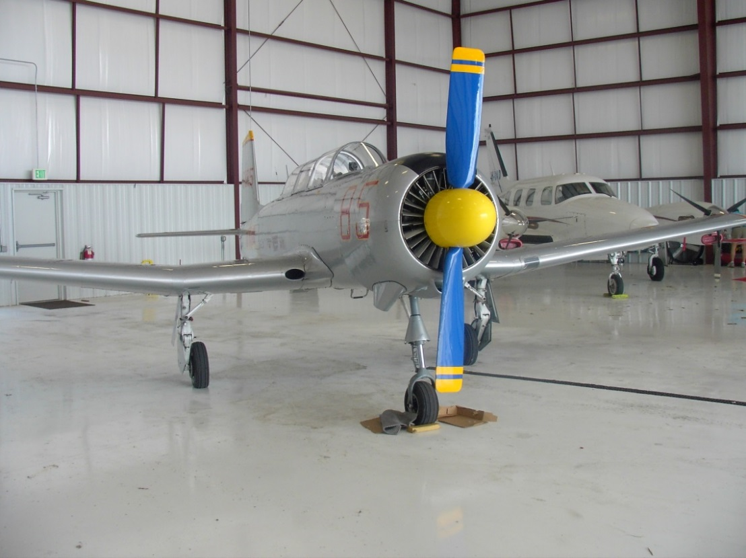
Fast Company – The GP-5
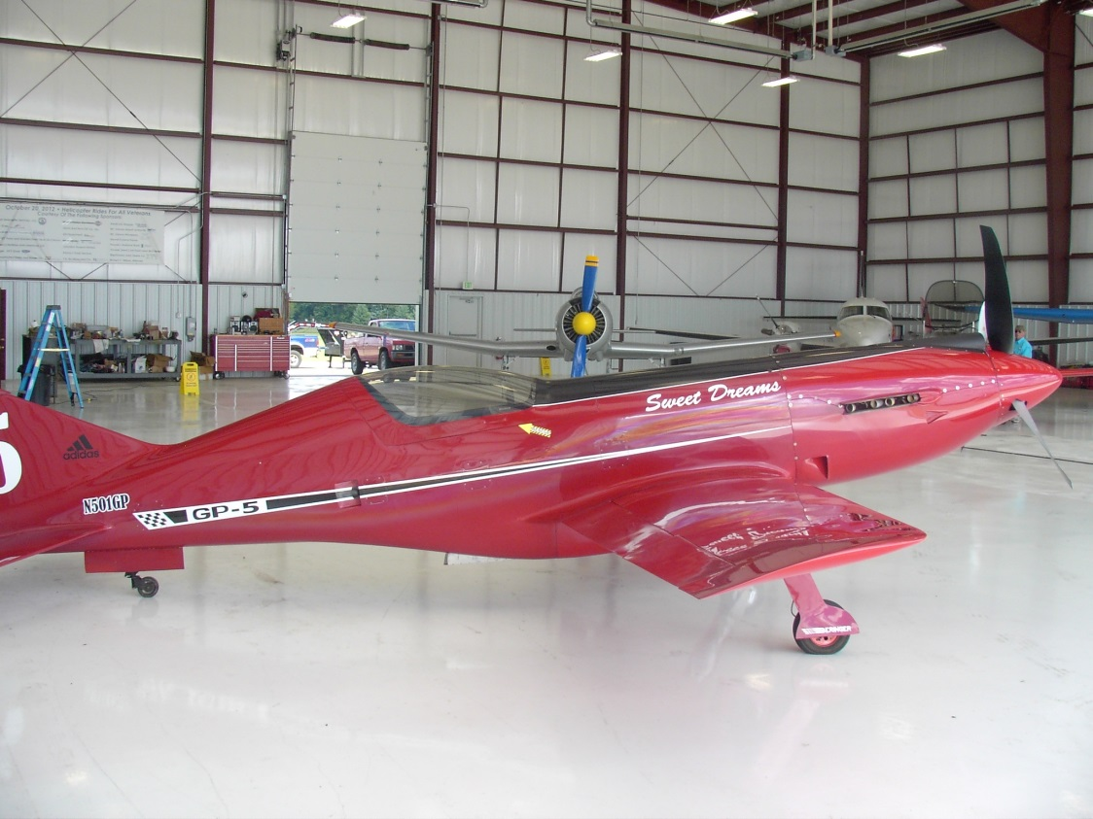

More Fast Company – SX300 and CJ-6A
